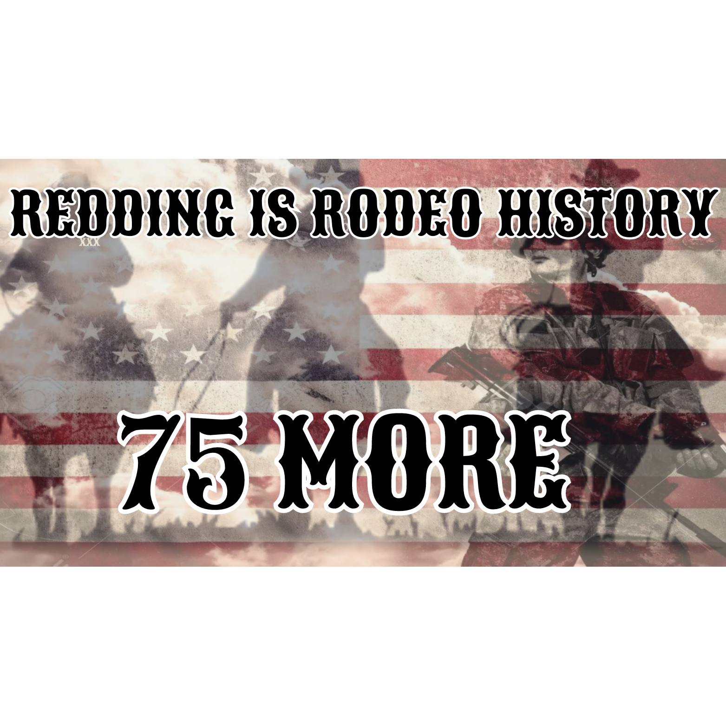
To: Redding City Council
Michael Dacquisto
Mark Mezzano
Tenessa Audette
Julie Winter
Jack Munns

I, ___________________________________ support the Redding Rodeo Association because;

For 75 years the Redding Rodeo Association has heralded the history and heritage of the City of Redding through their volunteer efforts and those efforts of the Asphalt Cowboys. These two organizations have been dedicated to the promotion of the rodeo and the betterment of the entire community.

It is time to offer the Redding Rodeo Association a series of long term contracts on the Rodeo Grounds and the immediate surrounding area that guarantees them, the Asphalt Cowboys and groups associated with the rodeo a long term home that can be developed to maximize it’s economic potential, the greatest return to the community and upgraded and expanded facilities for the rodeo and other outdoor community events.

Please move expediently to offer the Redding Rodeo Association a 15 year contract with an additional four 15 year extensions, totaling 75 years in honor of this years 75th anniversary of this great event.

Sincerely,

________________________________________
Signature
________________________________________
Address
________________________________________
City, State Zip Code
________________________________________
Phone Number
________________________________________
Email

